**Battery charging and Discharging Simulation**

* Models Li-ion battery charging/discharging behaviour
* Inputs: Capacity, Current, voltage
* Outputs: SOC(state of charge),efficiency
* Libraries: numpy, matplotlib
* Application: EV battery management systems

**SOURCE CODE:**

import numpy as np

import matplotlib.pyplot as plt

# Simulation Parameters

time_step = 1  # in seconds

total_time = 3600  # 1 hour in seconds

time = np.arange(0, total_time, time_step)

# Battery Parameters

capacity_ah = 2.0  # 2Ah battery

voltage_full = 12.6  # Fully charged voltage

voltage_empty = 11.5  # Fully discharged voltage

# Charge and Discharge Currents

charging_current = 1.0  # Amps

discharging_current = 0.5  # Amps

# Initialize SOC (0 = 0%, 1 = 100%)

soc = []

voltage = []

# Initial Conditions

soc_value = 0.2  # Start at 20% charged

charging = True

for t in time:

    if charging:

        soc_value += (charging_current * time_step / 3600) / capacity_ah

        if soc_value >= 1.0:

            soc_value = 1.0

            charging = False  # Switch to discharging

    else:

        soc_value -= (discharging_current * time_step / 3600) / capacity_ah

        if soc_value <= 0.0:

            soc_value = 0.0

            charging = True  # Switch to charging

    # Clamp SOC between 0 and 1

    soc_value = max(0, min(1, soc_value))

    soc.append(soc_value)

    # Linear approximation of voltage based on SOC

    voltage_value = voltage_empty + soc_value * (voltage_full - voltage_empty)

    voltage.append(voltage_value)

# Plot SOC over Time

plt.figure(figsize=(10, 5))

plt.plot(time / 60, np.array(soc) * 100, label='SOC (%)', color='blue')

plt.xlabel('Time (minutes)')

plt.ylabel('State of Charge (%)')

plt.title('Battery Charging and Discharging Simulation')

plt.grid(True)

plt.legend()

# Plot Voltage over Time (Optional)

plt.figure(figsize=(10, 5))

plt.plot(time / 60, voltage, label='Voltage (V)', color='green')

plt.xlabel('Time (minutes)')

plt.ylabel('Battery Voltage (V)')

plt.title('Battery Voltage vs Time')

plt.grid(True)

plt.legend()

plt.show()

**Battery charging & Discharging simulation**

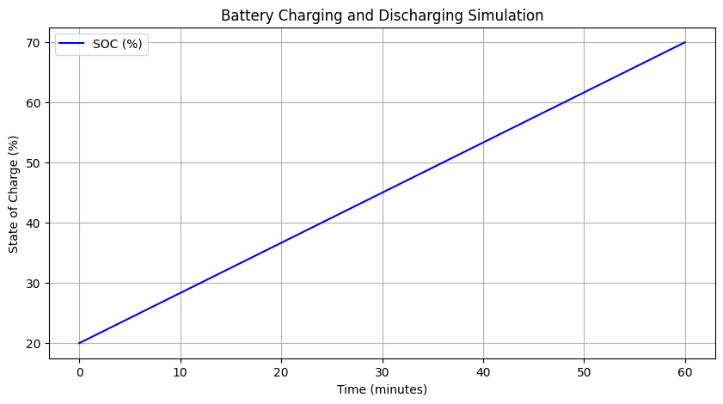

**Battery voltage vs Time**

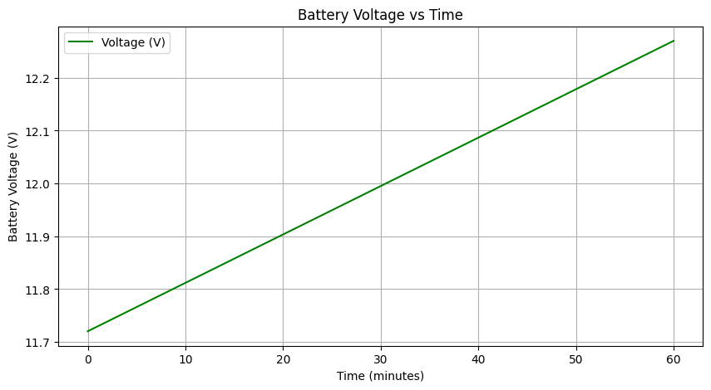

**Conclusion:** The above program shows about the Battery charging and discharging. The more water in the tank, the more charged it is. When you fill the tank (charging), the water level rises. When you use water from it (discharging), the level drops. The process switches between charging and discharging over time. This simulates how a battery works in real life—like in your phone, charging at night and discharging during the day.